A STUDY ON LANE UTILIZATION

*A project submitted in partial fulfillment of the requirements for the award of degree of*

**BACHELOR OF TECHNOLOGY**

***in***

**CIVIL ENGINEERING**

***Submitted by***

**M. Kanaka Mahalakshmi B. Yoshita**

**(18331A0159) (18331A0106)**

**S. Pavan Kumar K. N. V. Satyam**

**(18331A0114) (18331A0151)**

Under the Guidance of

**Mr. G. Rahul Reddy**

Assistant Professor



DEPARTMENT OF CIVIL ENGINEERING

MVGR COLLEGE OF ENGINEERING (AUTONOMUS)

VIZIANAGARAM-535005

(*Affiliated to JNT University, Kakinada, A.P)*

**JUNE, 2022**

**DECLARATION**

We hereby declare that the project titled “A STUDY ON LANE UTILIZATION” is the work done under the guidance of Mr. G. Rahul Reddy, Assistant Professor, Department of Civil Engineering, MVGR College of Engineering during 2021-2022 in partial fulfillment of the requirements for the award of design of project of Bachelor of technology ‘In Civil Engineering’. We ensure that the project is not been submitted earlier to any other institution or university.

**CERTIFICATE**

This is to Certify that the project entitled **“A study on lane utilization”** is the bonafide work carried during academic year 2021-2022 by **“M. Kanaka Mahalakshmi, B. Yoshita, S. Pavan Kumar and K. N. V. Satyam”** under the guidance of **Mr. G. Rahul Reddy** Assistant Professor is submitted to the Department of Civil Engineering, MVGR College of Engineering (Autonomous), Vizianagaram in partial fulfillment of the requirements for the award of degree of **‘Bachelor of Technology’** in **‘Civil Engineering’**.

HoD- Civil Engineering Project Guide

Dr. P. Markendeya Raju Mr. G. Rahul Reddy

Head of the Department Assistant Professor

**ACKNOWLEDGEMENT**

It’s our privilege to express our deep sense of gratitude and high regards to our project guide Mr. G. Rahul Reddy, Assistant Professor of Department of Civil Engineering, MVGR College of Engineering, Vizianagaram for his guidance, valuable suggestions and constant encouragement throughout the period of work. We also thank him for giving this opportunity to do such a wonderful project which is major requirement of the present society.

It’s our privilege to express our gratitude to Dr. P. MARKENDEYARAJU, Professor and Head of the Department, Civil Engineering and Dr. K. V. L. RAJU, Principal, MVGR College of Engineering and for their constant support and guidance to our work.

**ABSTRACT**

The traffic composition on multilane highways in India varies depending upon the vehicle type, engine, maneuvering ability, etc. This mix of vehicles with different operating capabilities results in a broad range of speed. The inconsistency of traffic flow behavior with broad range of speed on uninterrupted freeways might largely affect the traffic assignment system. To understand the real traffic behavior, it requires quantification of some basic characteristics like lane utilization, flow rates, classified volume count, speed of individual vehicle along with the stream speed and its composition.  
  
This research paper has been done to understand the undulations in traffic flow and the efficiency of lane distribution system over the speculated area of study.

**LIST OF TABLES:**

1. Data on lane distribution of different categories of vehicles collected on the area of work - Boyapalem

2.

**CHAPTER -1**

**INTRODUCTION**

The purpose of this project is to study the traffic characteristics on lane utilization. Lane Utilization can roughly be defined as how the rate of traffic flow is distributed among the available number of lanes in a given section. The importance of studying lane utilization comes from the fact that it is one of the important parameters for calibrating the parameters of micro-simulation traffic models. Traffic microsimulation models simulate the behavior of individual vehicles within a predefined road network and are used to predict the likely impact of changes in traffic patterns resulting from changes to traffic flow or from changes to the physical environment. In this project, a discrete analysis on lane utilization factor is made by observing the traffic in a time period of two hours each on peak hour and off-peak hour. The factors such as vehicle composition in each lane, type of vehicle travelling in each lane and sub-lanes are considered. A simple tallying is done for obtaining the volume of the traffic in individual lanes. The data is then extracted to excel sheets, bar diagrams and pie charts are fabricated for the better understanding of the study on lane utilization.

**CHAPTER -2**

**LITERATURE REVIEW**

**2.1 Overview**

A large amount of research has been completed in the field of lane distribution, prior. The current literature review summarizes the current state of knowledge and verifies various methods that have been used. It also mentions the need to investigate for the current study case.

**2.2 Literature Review**

One of the first studies on the lane distribution for multi-lane carriageways was that by the US Public Roads Administration (Normann, 1942). Several highway authorities carried out significant studies on lane distribution in the late 1960s and 70s on rural and urban highways and freeways with two-, three-, four- and five-lane unidirectional carriageways (Taragin, 1958) (Lynch et al., 1969). In these studies, the non-homogeneous use of a multi-lane road was highlighted, along with the observation that the percentage of use of the shoulder lane (by which the authors mean the lane nearest to the hard shoulder, which is the right-hand lane for countries driving on the right-hand side of the road) was inversely proportional to the total flow. With increasing flow, vehicles seemed to prefer the middle or median lanes (by median lane the authors mean the lane closest to the central reservation and the left-hand lane for countries driving on the right-hand side of the road). The first multiple regression models were proposed in these studies to fit the functional formulation of lane use percentage, known as Lane Flow Ratio (LFR).

A few years later, Pignataro (1973) carried out several studies on the American three-lane freeway system, which reflected the typical variation in traffic flows by lane. Under conditions of low flow, he observed that almost half the total flow travelled by preference on the middle lane. With increasing flow, he observed that flow on the two inner (fastest) lanes (middle and median lanes) was equally distributed with reduced usage of the shoulder (slowest) lane.

A detailed study of the variability in traffic flow characteristics and parameters across lanes was conducted by Allen et al. (1985) in Ontario, Canada, in which they demonstrated some differences in speed, flow and density distribution. In the study, and in subsequent research, Hall and Gunter (1986) also showed that the lane capacity values are different, these being lower for the shoulder lane and higher for the middle and median lanes.

Nordaen and Rundmo (2009) and Ozkan et al. (2006) suggested that drivers’ behaviour is significantly affected by cultural differences among countries. This might explain the differences in the pattern of lane changes for different countries as reported by Ferrari (1989). Gunay (2004) in his study on Turkish highways also reported that the lane utilization coefficients are significantly different from those obtained in developed countries. Gunay explained the reasons behind that behavior by the so called “untidy lanes” where no marking lines between lanes were present with poor lane discipline. Some studies (Knoop et al. 2010 and Lee and Park 2012) considered the lane utilization as a function of traffic density. From the literature review it may be noted that most of the research works on lane usage and distribution are conducted in developed countries. Also, it may be noted that there have been very few studies conducted for studying lane distribution on multilane roads.

In a “Study of Lane Utilization on Delhi-Gurgoan expressway” conducted by Sagar Kurle, Krishna Nikhil Sumanth Behara, J. Rajendra Prasad, Shriniwas Shrikant Arkatkar, they highlight that the lane utilization is affected by several factors such as vehicle composition, traffic flow rate and vehicular speeds. They based their findings on eight hours of video graphic data collected from a road stretch on Delhi-Gurgaon Expressway, incorporating both peak and off peak hours.

**2.3 Conclusion**

The results of the present study in the form of lane utilization and lane discipline behavior by different vehicle types may help in differentiating the characteristics of traffic on expressways in relation to the other roads in India. It may be also helpful to refine the microscopic simulation models and its parameters by using data collected about Indian roads’ traffic flow in order to validate them at micro-level.

**CHAPTER -3**

**DATA AND METHODOLOGY**

This chapter describes how data were collected and how they were evaluated to identify factors associated with Lane Utilization using data from districts of Vizianagaram and Visakhapatnam along the highways NH-16, NH-26.

**3.1 Data Collection**

The main data collection task was to manually collect the categorical vehicular count i.e., car, two-wheeler, three-wheeler, heavy good vehicle through an instantaneous cross section of the lane in individual lanes at peak hour and off hour. The time periods for data collection were opted out such that it covers wider variation of traffic flow conditions. The lanes are distributed as lane 1, lane 1.5, lane 2, lane 2.5 and so on. The data was then used in graphical, spatial and a statistical analysis for Lane Utilization.

**Table 1: Data on lane distribution of different categories of vehicles collected on the area of work - Boyapalem**

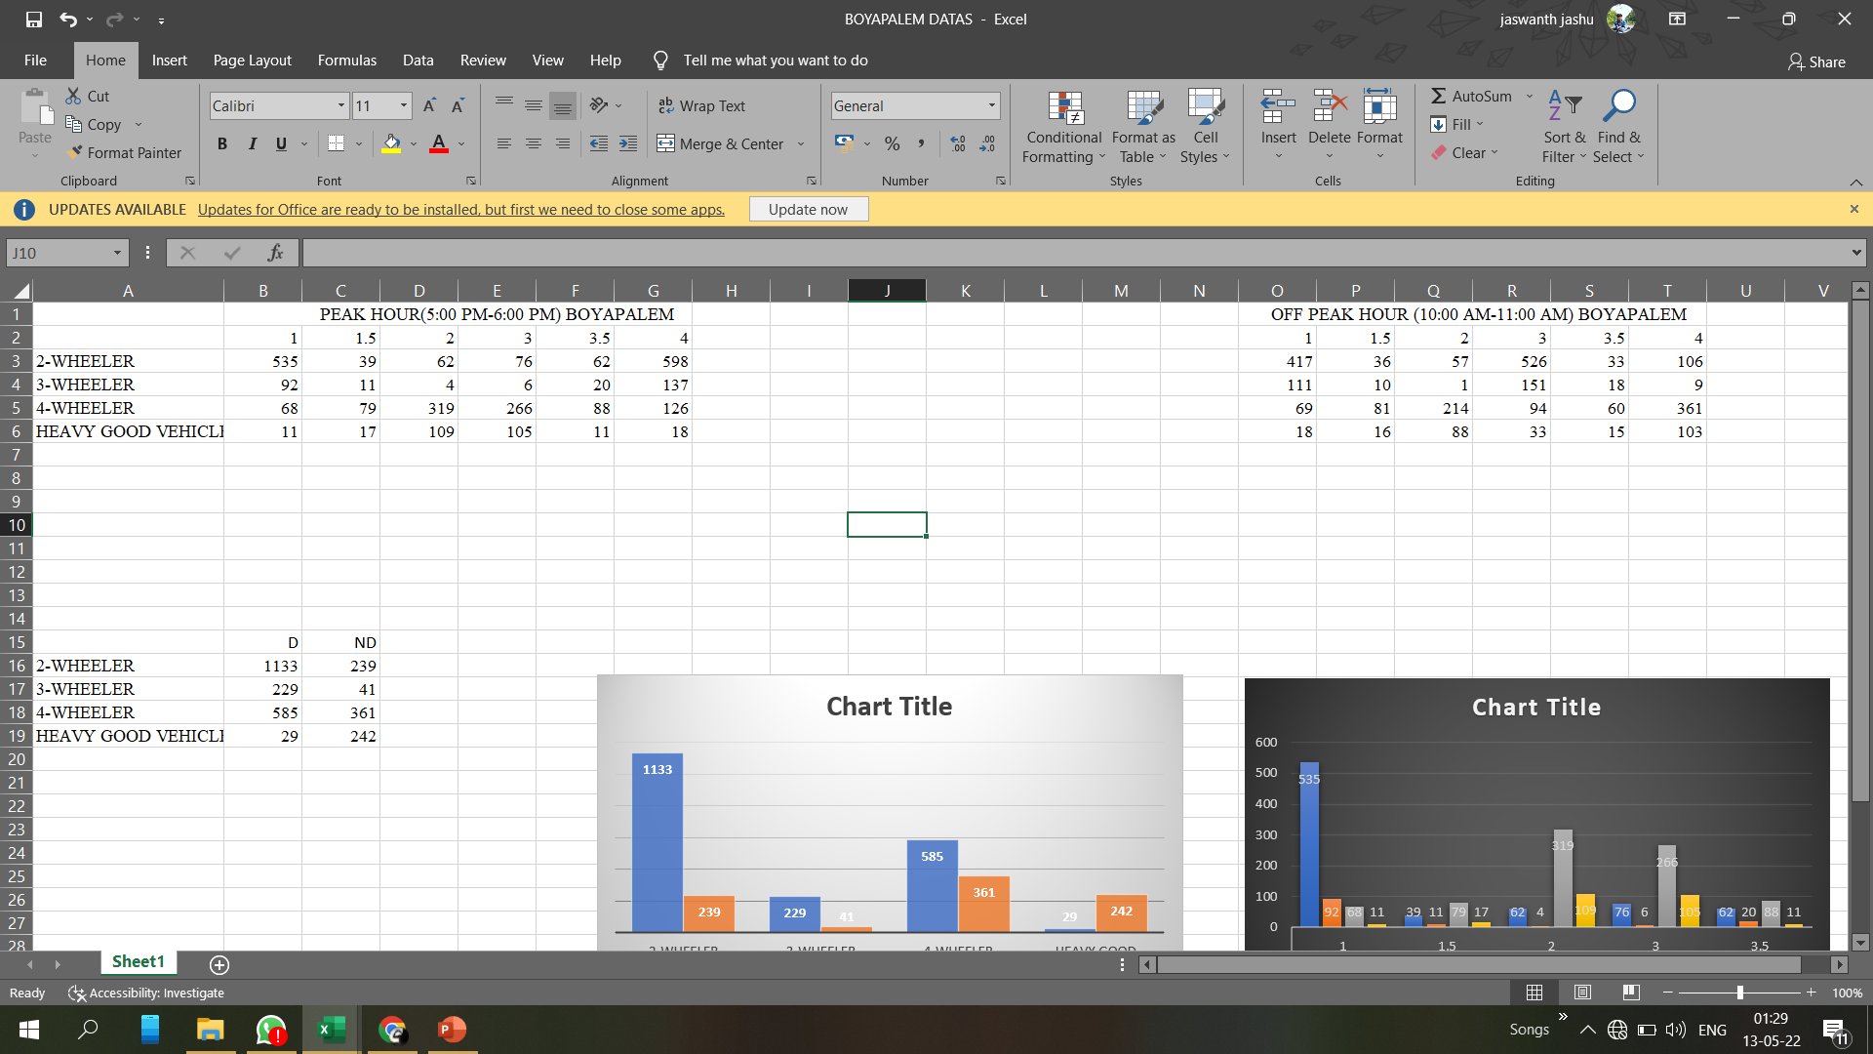

**Figure 1: NH16 BOYAPALEM AREA 4 LANE ROAD**

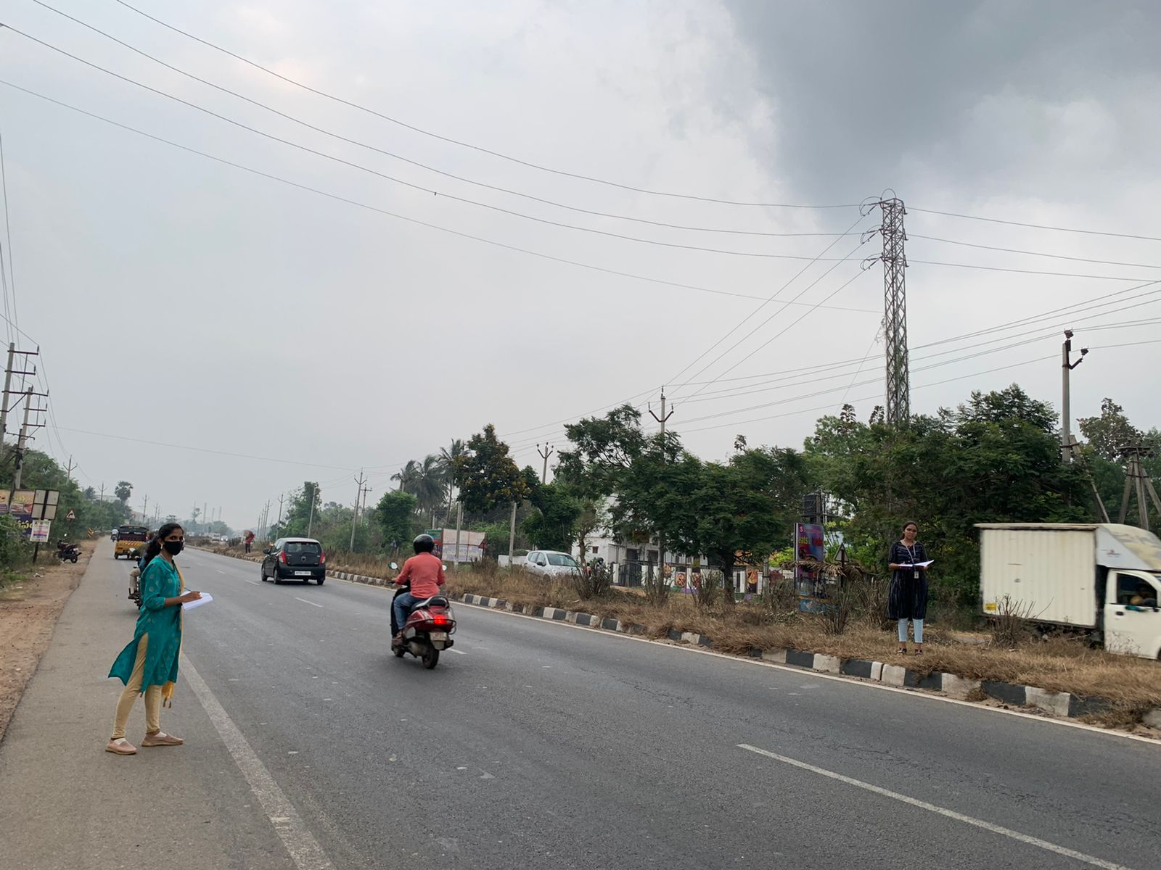

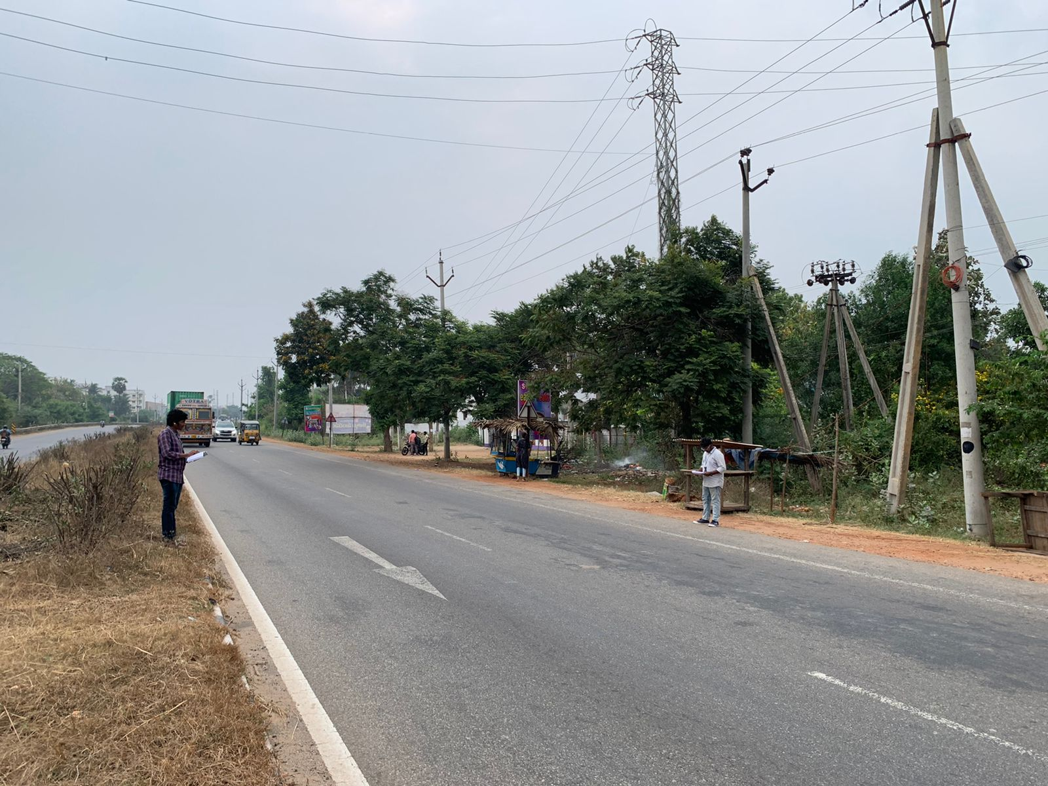

**Table 2: Data on lane distribution of different categories of vehicles collected on the area of work – Gambhiram**



**Figure 2: ANANDAPURAM-PENDURTHI HIGHWAY (NH5/New NH16)**

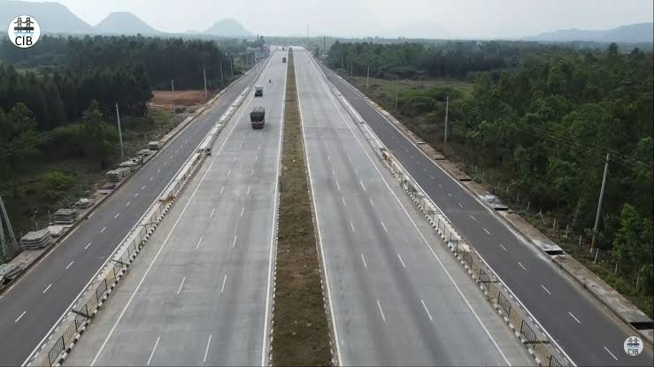

**Table 3: Data on lane distribution of different categories of vehicles collected on the area of work – Jonnada**

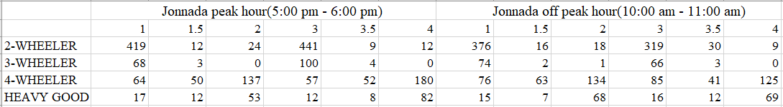

**Table 4: Data on lane distribution of different categories of vehicles collected on the area of work - Police barracks**

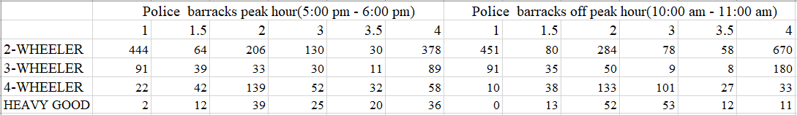

**3.2 Statistical Analysis**

**3.2.1 Categories of Vehicles Vs Lane Utilized**

To understand vehicle preference for particular lane the data collected was charted by categories of vehicles against lanes utilized.

Figure 3: NH16 Boyapalem - 2 Wheeler Vehicles Vs Lane Segment Utilized

Figure 4: NH16 Boyapalem - 3 Wheeler Vehicles Vs Lane Segment Utilized

Figure 5: NH16 Boyapalem - 4 Wheeler Vehicles Vs Lane Segment Utilized

Figure 6: NH16 Boyapalem - Heavy Good Vehicles Vs Lane Segment Utilized

Figure 7: Gambhiram - 2 Wheeler Vehicles Vs Lane Segment Utilized

Figure 8: Gambhiram - 3 Wheeler Vehicles Vs Lane Segment Utilized

Figure 9: Gambhiram - 4 Wheeler Vehicles Vs Lane Segment Utilized

Figure 10: Gambhiram – Heavy Good Vehicles Vs Lane Segment Utilized

Figure 11: Jonnada - 2 Wheeler Vehicles Vs Lane Segment Utilized

Figure 12: Jonnada - 3 Wheeler Vehicles Vs Lane Segment Utilized

Figure 13: Jonnada - 4 Wheeler Vehicles Vs Lane Segment Utilized

Figure 14: Jonnada – Heavy Good Vehicles Vs Lane Segment Utilized

Figure 15: Police Barracks – 2 Wheeler Vehicles Vs Lane Segment Utilized

Figure 16: Police Barracks – 3 Wheeler Vehicles Vs Lane Segment Utilized

Figure 17: Police Barracks – 4 Wheeler Vehicles Vs Lane Segment Utilized

Figure 18: Police Barracks – Heavy Good Vehicles Vs Lane Segment Utilized

**3.2.2 Lane Utilization charted against various vehicle categories**

To understand lane utilization at various points of time by different categories of vehicles, the data collected was charted by lane utilization against categories of vehicles.

Figure 19: NH16 Boyapalem – Lane 1 Utilization

Figure 20: NH16 Boyapalem – Lane 2 Utilization

Figure 21: NH16 Boyapalem – Lane 3 Utilization

Figure 22: NH16 Boyapalem – Lane 4 Utilization

Figure 23: Gambhiram – Lane 1 Utilization

Figure 24: Gambhiram – Lane 2 Utilization

Figure 25: Gambhiram – Lane 3 Utilization

Figure 26: Gambhiram – Lane 4 Utilization

Figure 27: Gambhiram – Lane 5 Utilization

Figure 28: Gambhiram – Lane 6 Utilization

Figure 29: Jonnada – Lane 1 Utilization

Figure 30: Jonnada – Lane 2 Utilization

Figure 31: Jonnada – Lane 3 Utilization

Figure 32: Jonnada – Lane 4 Utilization

Figure 33: Police Barracks – Lane 1 Utilization

Figure 34: Police Barracks – Lane 2 Utilization

Figure 35: Police Barracks – Lane 3 Utilization

Figure 35: Police Barracks – Lane 4 Utilization

**3.3 Lane Discipline Analysis**

<<Explain how the lane discipline analysis was done by your team. Only the numerical analysis>>

<<The chart results of lane discipline are attached in the next section>>

**CHAPTER -4**

**RESULTS**

Section 3.3 provides details of numerical analysis done on the collected data to establish the lane discipline of various vehicles. The following are the plotted results of lane discipline calculated for the data.

Figure 36: NH16 BOYAPALEM - Vehicle Category wise Lane Discipline Analysis

Figure 37: Gambhiram - Vehicle Category wise Lane Discipline Analysis

Figure 38: Jonnada - Vehicle Category wise Lane Discipline Analysis

Figure 39: Police Barracks - Vehicle Category wise Lane Discipline Analysis

**CHAPTER – 5**

**SUMMARY AND CONCLUSIONS**